Day 25 - 07th Aug 2025

Task 01:

Builder: Done

Task 02:

Adaptor: Done

public interface Iphone {
public void onCharge();
public void offCharge();
}

public class Iphone16Charger implements Charger{
Iphone16Charger() {......};

public void charge() {
sout(" i m acharging Iphone 16");
}

interface Charger {
void charge();
void removeCharge();
}

class Iphone16Adapter implements Charger {
Iphone16Charger iphone16Charger;

Iphone16Adapter() {
iphone16Charger = new Iphone16Charger();
}
@Override
void charge() {
iphone16Charger.charge();
}

@Override
void charge() {
iphone16Charger.charge();
}
}

class Iphone16 implements Iphone {
Charger Iphone16Adapter;

Iphone16( Charge iphone16Adapter) {
this.iphone16Adapter= iphone16Adapter;
}

@Override
void onChrage() {
Iphone16Adapter.charge();
}

@Override
void offChrage() {
Iphone16Adapter.removecharge();
}

}

ClientAdapterDpMain {
psvm () {
Iphone16 iphoneobj = new Iphone16(new Iphone16Adapter());
iphoneobj.onCharge();
iphoneobj.offCharge();
}
}

Task03:

Create a class diagram in uml..

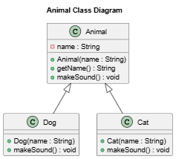

Task 04:

What are the commonly used visibility Notations in class diagrams?

Eg: =,-, ~, #,
The most commonly used visibility notations are:
Symbol | Visibility | Meaning
+ | Public | Accessible from anywhere
- | Private | Accessible only within the same class
# | Protected | Accessible within the same class and subclasses
~ | Package (default) | Accessible only within the same package (Java default access modifier)

Task 05:

What do you know about Parameter Directionality?

List them
In UML, parameter directionality specifies how data flows between a caller and a method (or operation).
It tells whether the parameter is an input to the method, an output from the method, or both.
The main directionality indicators are:
Direction | Meaning | UML Notation
in | The parameter is passed into the operation (read-only for the operation). | in before the parameter name
out | The parameter is used to return data from the operation (value is set inside the method). | out before the parameter name
inout | The parameter is passed in, can be modified, and the modified value is returned to the caller. | inout before the parameter name

Task 06:

Class Diagram Relationships
In UML class diagrams, relationships describe how classes are connected and interact.
Here are the main types of class diagram relationships:

1. Association
- Meaning: A basic link showing that one class uses or is connected to another.
- Representation: Solid line between classes.
- Optional details: Multiplicity (1, 0..*, 1..*), role names, and navigability arrows.
- Example:
Student —enrolls in→ Course

2. Aggregation (Has-a, Weak Ownership)
- Meaning: A whole-part relationship where the part can exist independently of the whole.
- Representation: Hollow diamond at the whole side.
- Example:
Team ◇── Player
(Players can exist without the Team.)

3. Composition (Has-a, Strong Ownership)
- Meaning: A whole-part relationship where the part’s lifecycle is tied to the whole.
- Representation: Filled diamond at the whole side.
- Example:
House ◆── Room
(Rooms are destroyed when the House is destroyed.)

4. Inheritance / Generalization
- Meaning: One class is a specialized version of another.
- Representation: Solid line with a hollow triangle pointing to the superclass.
- Example:
Car ◁── ElectricCar

5. Realization (Interface Implementation)
- Meaning: A class implements an interface.
- Representation: Dashed line with a hollow triangle pointing to the interface.
- Example:
PaymentService ◁⋯⋯ UPIPaymentService

6. Dependency
- Meaning: One class temporarily depends on another (e.g., uses it as a parameter or local variable).
- Representation: Dashed line with an arrow pointing to the depended-on class.
- Example:
OrderService - - - - > EmailService

💡 Quick Summary Table:
Relationship | Symbol in UML | Meaning
Association | ──── | General connection
Aggregation | ◇──── | Whole-part, weak
Composition | ◆──── | Whole-part, strong
Inheritance | △──── | "Is-a" hierarchy
Realization | △⋯⋯ | Implements interface
Dependency | →⋯⋯ | Uses temporarily
Example code:
@startuml
' Classes
class Student {
+name : String
+rollNo : int
}

class Course {
+courseName : String
+credits : int
}

class Team {
+teamName : String
}

class Player {
+playerName : String
}

class House {
+address : String
}

class Room {
+roomNumber : int
}

class Vehicle {
+speed : int
}

class Car {
+model : String
}

interface PaymentService {
+processPayment(amount: double)
}

class UPIPaymentService {
+processPayment(amount: double)
}

class OrderService {
+placeOrder()
}

class EmailService {
+sendEmail(message: String)
}

' Relationships
Student "1" -- "0..*" Course : enrolls in ' Association
Team "1" o-- "0..*" Player : has ' Aggregation
House "1" *-- "1..*" Room : contains ' Composition
Vehicle <|-- Car ' Inheritance
PaymentService <|.. UPIPaymentService ' Realization
OrderService ..> EmailService : uses ' Dependency

@enduml

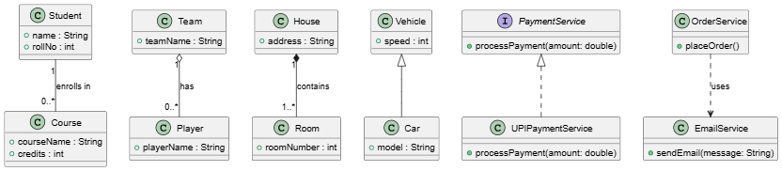

Task 07:
represent a Package diagram
@startuml

' Define packages
package "User Management" {
class User {
+userId : int
+name : String
}
class Profile {
+email : String
+phone : String
}
}

package "Order Processing" {
class Order {
+orderId : int
+date : Date
}
class Payment {
+amount : double
}
}

package "Notification Service" {
class EmailService {
+sendEmail(message: String)
}
class SMSService {
+sendSMS(message: String)
}
}

' Relationships
User --> Order : places
Order --> Payment : paid by
Payment --> EmailService : sends receipt
Payment --> SMSService : sends confirmation

@enduml

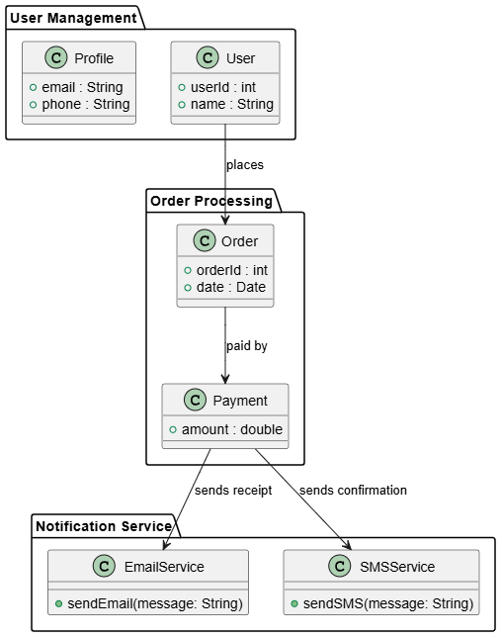

Task 08:

what is state notation .. initial and final ?

In UML State Machine Diagrams, state notation represents the different conditions or situations an object can be in, and how it transitions between them.
The initial and final states are special notations used to mark the start and end of a state machine’s execution.

1. Initial State
- Meaning: The starting point of the state machine when the object is created or the process begins.
- Notation: Filled black circle (●).
- Usage: Connected by a transition arrow to the first active state.

2. Final State
- Meaning: The end point of the state machine — no more transitions happen after this.
- Notation: Filled black circle with an outer ring (◎).
- Usage: Usually has incoming transitions from the last active state.

Example State Diagram (PlantUML Code)
plantuml
CopyEdit
@startuml
[*] --> Idle : initial state
Idle --> Processing : start order
Processing --> Shipped : order completed
Shipped --> [*] : final state
@enduml

- [*] → Represents initial and final states.
- --> → Transition arrow.
- Labels on arrows (start order, order completed) describe events triggering transitions.
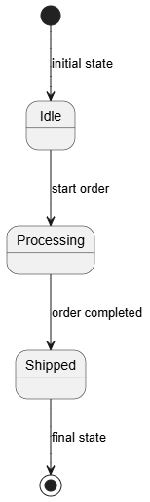

================================

Home task:
Home task01:

Facade code:

class BankFacade {
//list of all services
private FdService fdService;

//constructor
this.fdService = new FdService();

void getfdServiceDetails(String ...) {
fdservice.getfdServiceDetails(accoundno);
}
}

Home task 02:

Composite Method Design Patteren:

interface Component {
void brandName();
}

class leaf implements Component {
// declare variables

construtor

@Override
brandName()

}
class Composite implements Component {
//variable declaration

Composite() {
}
Composite(...params) { }

@Override
brandName () {
for each loop - for all components {
compobj.brandName();
}
}
add(Component subComponent) {
componets.add(subComponent);
}

}

Home Task 03:

Proxy:

interface DBExecutor {
abstract void runQuery(String Type);
}
class DB{
DB(){ }
void runIt(String Type , String id) {
sout("we are running a query "+ Type);
}
}
class DBProxy implements DBExecutor {
String id;
DB db;
//constructor default
public DBProxy(String id) {
this.id = id;
db = new DB();
}
@Override
public void runQuery (String Type) {
if (Type.equals("Delete") && (!Objects.equals(this.id, "ADMIN")) {
sout("sorry access denied");
return;
}
db.runIt(Type, this.id);
}
}
class ClientProxyDP {
psvm(...) {
DBExecutor obj1 = new DBProxy("ADMIN");
obj1.runIt("READ");
obj1.runIt("UPDATE");
obj1.runIt("DELETE");

DBExecutor obj2 = new DBProxy("MANAGER");
obj2.runIt("READ");
obj2.runIt("UPDATE");
obj2.runIt("DELETE");

}
}

Hmotask 04:

Flyweight

HomeTask 05:

Bridge

Excalidraw link updated at 11.00

https://excalidraw.com/#json=suv0yH5AB-GjV4ZQdPKo1,xOzVuTY2l6HZ08vr3p6nuQ

Excalidraw updated at 13.08
https://excalidraw.com/#json=QURJ6oE0ck3nlsez82HVI,qiWEIN4OR56V2751XiD8TA

Git hub links will be checked on sunday 10th aug evening after 6pm

Excalidraw updated at 17.08:

https://excalidraw.com/#json=vc4FTtHNUf8rUYzdF4Kng,JQLY2aD4fRzDFyBm4yW2WA

